**ASSIGNMENT:-4(part-2)**

**EECE:-212**

**NAME: Shaharehar Rahaman Anik**

**Level: 2**

**ID No: 201916058**

**Here are some mathematical problem are solved by MATLAB 2020a.according to the questions. The answers are given bellow:**

**1) For the following values of x and corresponding values of y : (1,1),(2,28),(3,64),(4,43),(5,70),(6,95),(7,127),(8,149), find the value of y when x=2.8 using Lagrange's Interpolation formula in MATLAB.**

**Solution:**

Here are some value of x & corresponding values of y according to a function. Now I have to find out the value of y when x=2.8 using Lagrange’s Interpolation formula in MATLAB.

The MATLAB code is given bellow:

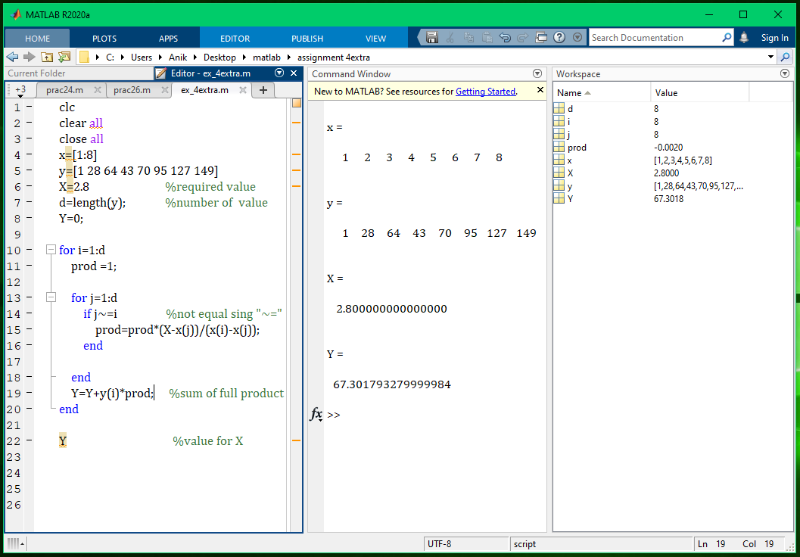

**When x=2.8; y= 67.301793279999984**

**2) Solve the above problem by hand calculation. (First you must find a equation as shown in the slide of the class lecture, then put the value of x in the equation and find the final result)**

**Solution:**

Here we have,

(x, y)= (1,1),(2,28),(3,64),(4,43),(5,70),(6,95),(7,127),(8,149)

We know the LaGrange’s interpolation formula is:

 + ……….+ 

According to values,

(X0, Y0)= (1, 1); (X2, Y2) = (3, 64); (X4, Y4) = (5, 70); (X6, Y6) = (7,127);

(X1, Y1)= (2, 28); (X3, Y3) = (4, 43); (X5, Y5) = (6, 95); (X7, Y7) = (8,149);

Now we have to find the value of **y when x=2.8**

**So, applying LaGrange’s interpolation formula:**

Y=

**Inputting values:**

Y=

Now calculating this long term equation, we have,

**Y= -x7+ x6-x5 +x4+x3-x2-x+1925**

­ ; this is the required polynomial equation.

Then when **x=2.8** the value of **y** is,

**Y = -2.87+ 2.86-2.85 +2.84+2.83-2.82-2.8+1925**

= **67.301793279999984**

**(Answer...)**

**; This is the required solution.**

**3) Compare between Newton's Interpolation and Lagrange's Interpolation.**

**Solution:**

Here have to compare between Newton's Interpolation and Lagrange's Interpolation. The comparison is given below:

**Newton's Interpolation:**

1. Here the set of a value of a function are define in a table.
2. Easily any data can be added in the table.
3. The calculation is comparatively short.
4. The difference between two x values, have to be equal.
5. The equation is comparatively tough.
6. There are two types of formula in here,
7. Newton’s forward interpolations:



1. Newton’s backward interpolations:



**Lagrange's Interpolation:**

1. Here no need any kind of table to input data.
2. If any data have to be added, there have to change the full equation.
3. Its calculation is comparatively long.
4. There no need to be equal the difference between the values of x.
5. Though the calculation is long but the equation is comparatively easy.
6. There is one type of formula:

 + ……….+ 